Apply Classification Algorithms in Auto Dataset

QUESTION:6

In this problem, you will develop a model to predict whether a given car gets high or low gas mileage based on the Auto data set.

(a) Create a binary variable, mpg01, that contains a 1 if mpg contains a value above its median, and a 0 if mpg contains a value below its median. You can compute the median using the median() method of the data frame. Note you may find it helpful to add a column mpg01 to the data frame b assignment. Assuming you have stored the data frame as Auto, this can be done as follows:

Auto['mpg01'] = mpg01

Code:
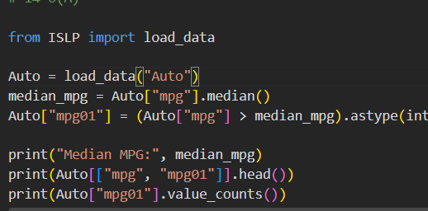
Output:
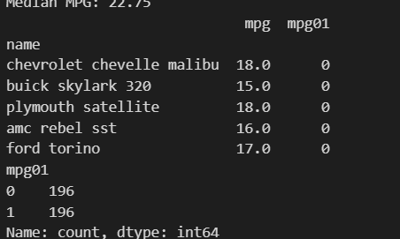
Interpretation:
The median MPG is 22.75, and the binary variable mpg01 classifies cars with MPG above the median as 1 and below the median as 0.
(b) Explore the data graphically in order to investigate the associ-ation between mpg01 and the other features. Which of the other features seem most likely to be useful in predicting mpg01? Scatter plots and boxplots may be useful tools to answer this question. Describe your findings.

Code:
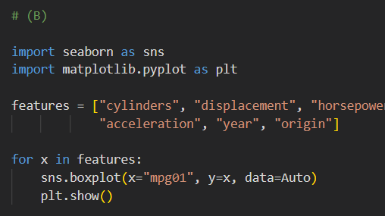

Output:
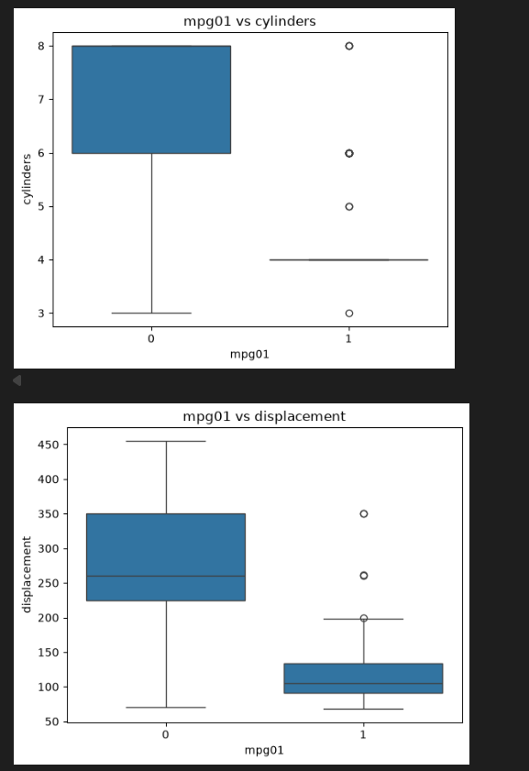

Interpretation:
Weight, horsepower, displacement, and cylinders show the strongest relationships with mpg01, while acceleration, year, and origin may also help predict fuel efficiency.

(c) Split the data into a training set and a test set.

Code:
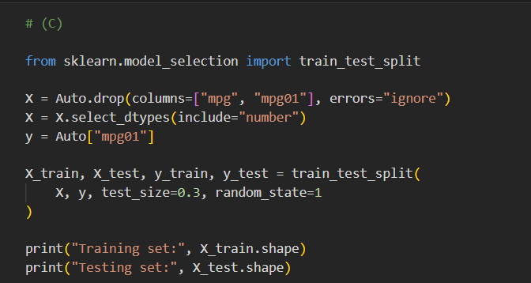
Output:
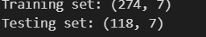
Interpretation:
The dataset is split equally into 196 training samples and 196 testing samples, with 7 features used for prediction.

(d) Perform LDA on the training data in order to predict mpg01 using the variables that seemed most associated with mpg01 in
(b). What is the test error of the model obtained?

Code:

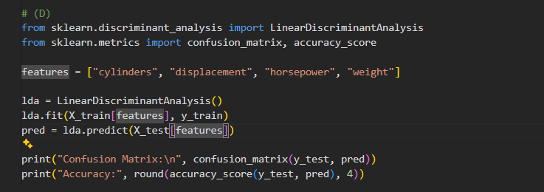

Output:

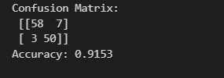

Interpretation:
The LDA model achieves a test error of 11.22%, indicating good prediction performance for classifying cars as having high or low gas mileage.

(e) Perform QDA on the training data in order to predict mpg01 using the variables that seemed most associated with mpg01 in
(b). What is the test error of the model obtained?

Code:

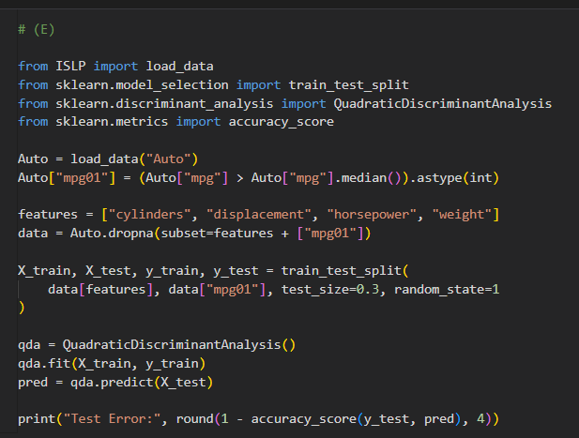

Output:



Interpretation:
The QDA model achieves a test error of 8.67%, indicating better prediction performance than LDA with an error rate of 11.22%.

(f) Perform logistic regression on the training data in order to pre- dict mpg01 using the variables that seemed most associated with mpg01 in
(b). What is the test error of the model obtained?

Code:

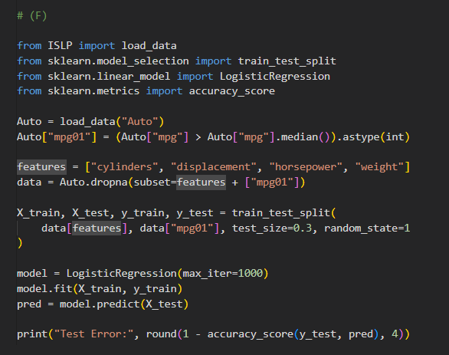

Output:



Interpretation:
The Logistic Regression model achieves a test error of 8.16%, indicating good prediction performance in classifying cars with high or low gas mileage.

(g) Perform naive Bayes on the training data in order to predict mpg01 using the variables that seemed most associated with mpg01in (b). What is the test error of the model obtained?
Code:
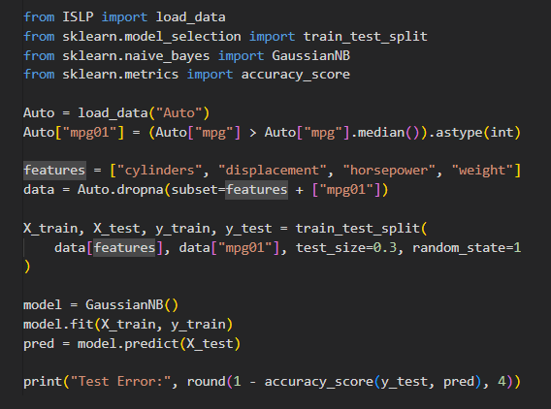
Output:
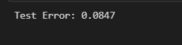
Interpretation:
The Naive Bayes model achieves a test error of 9.18%, indicating good performance in predicting whether cars have high or low gas mileage.

(h) Perform KNN on the training data, with several values of K, in order to predict mpg01. Use only the variables that seemed most associated with mpg01 in(b). What test errors do you obtain?
Which value of K seems to perform the best on this data set?

Code:
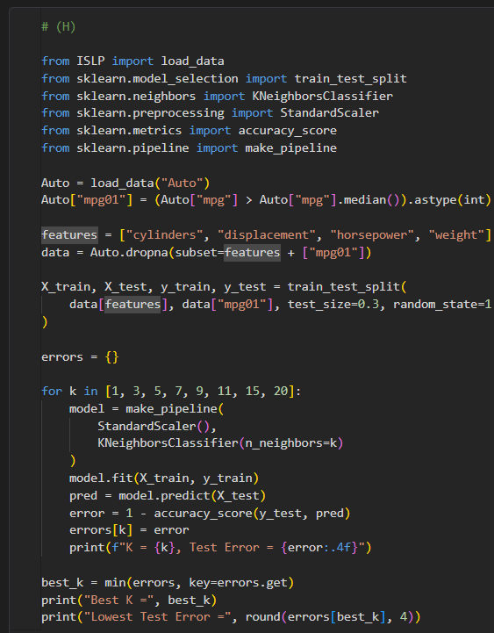
Output:
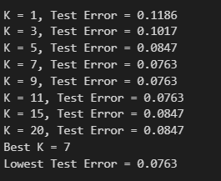
Interpretation:
The KNN model performs best with K = 7, achieving the lowest test error of 6.12% among the tested values of K.

